3.2-4) A *first order hold* (FOH) circuit can also be used to reconstruct a signal $x(t)$ from its samples. The impulse response of this circuit is:

$h\left(t\right)= Λ\left(\frac{t}{2T}\right)$, where T is the sampling interval

1. Let $f_{s}=\frac{1}{T_{s}}$ be a sampling frequency that exceeds the Nyquist sampling theorem requirement

Then $x_{\tilde{δ}}\left(t\right)$ will be scaled deltas of $x(t)$ at $t=nT$.

From class we know that $X_{\tilde{δ}}\left(ω\right)$ is a periodic replication of $X\left(ω\right)$ spaced by sampling frequency $ω_{s}=\frac{2π}{T}$ and that since we chose a sampling frequency that meets Nyquist’s requirement, the periodic replications in $X_{\tilde{δ}}\left(ω\right)$ will not overlap.

If we let T = 1, then in MATLAB $h\left(t\right)=Λ\left(\frac{t}{2T}\right)$ looks like:

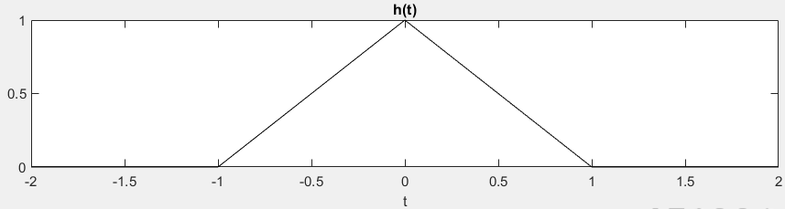

Then $H\left(ω\right)$ is:

We know that $X_{\tilde{δ}}\left(ω\right)$ is a periodic replication of $X\left(ω\right)$ spaced by sampling frequency $f_{s}= T^{-1}=10Hz, ω_{s}=2πf_{s}$

So, $X\left(ω\right)$:

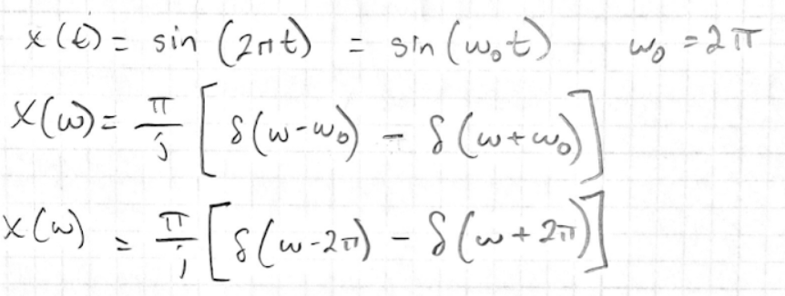

In MATLAB,

